January 2016- GATE Group Lesson-Backwards Brain Bicycle

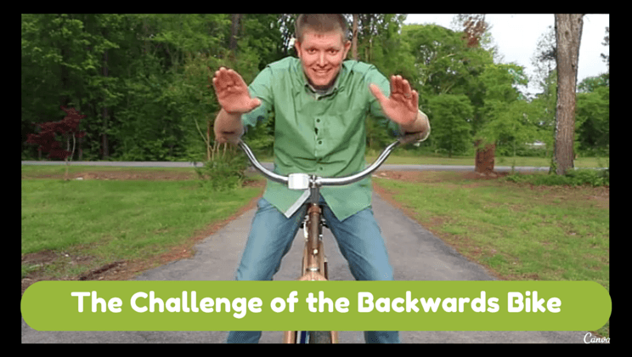
We began our lesson today by reviewing our “Recording Sheets” from our November/December: “How My Brain is Unique” lesson. Talking together about how the students felt when working with some of the challenge activities was very interesting. Some of their comments are below:
- “It’s difficult to balance the ball.”
- “It’s fun to try to beat my previous score.”
- “This is stressful.”
- “I learned staying in one area helps.”
- “I was horrible at this.”
- “I learned to look at all of the chances.”
- “This was hard. It required patience.”
- “It takes practice.”
- “It was frustrating.”
- “I had to persevere.”

We specifically discussed how some activities became “somewhat” easier as their time practicing went on, but how others would have needed LOTS more time for practice. In essence the goal was for your children to understand that learning something new causes the brain to grow more connections among the neurons. With more connections, the neurons can send and receive more messages. These connections help to STRETCH a part of their brains and make it more elastic, so that it can hold more information and ideas.

Trying new things, and learning that we all make mistakes when we are learning, is the way to train our brain. We will remember the mistake and try a different method or strategy, until we get it to work or get it right. Our brains remember the new strategy or method and continue to build on that one, not on the strategy that was unsuccessful. THAT IS HOW WE LEARN!!!!

The next activity we were involved in was a viewing of a video called: Backwards Brain Bicycle. I wanted the students to understand how we can all adjust our thinking to positively reframe events that might be hard or negative. Our brains have “neuroplasticity”, defined as the brain’s ability to change or adapt based on experiences. This understanding of “neuroplasticity” can help our students become better and smarter about practice, practice, practice, and the video “Backwards Brain Bicycle” was the perfect visual example of “neuroplasticity” at work.

This short video demonstrated how neural pathways that are traveled frequently become hardwired into habits difficult to change without deliberation and effort.

We had a great discussion afterward about how much time was spent practicing to learn backward bicycling, and how we could use this example in our own lives when we are dealing with studying, understanding new information, or even how at times we may need to practice advocating for ourselves, or practice being better friends by changing the way we look at people who may have previously been aggravating.

Our world is filled with varying personalities and many, many opportunities for us all to learn and grow. It’s amazing that we all have a brain that can help us get through each day if we only put it into action and get it stretching!!!

